
ADD:45REMIN ROAD(N) JISHOU, HUNAN, CHINA Msn: fuyuqin@live.cn
TeL: 0086-743-8722840 Fax: 0086-743-8223336 E-Mail: fuyuqin@xiangximinmetals.com

Please note the picture of our product for Al-Mn-Tablets and the specs as follows:

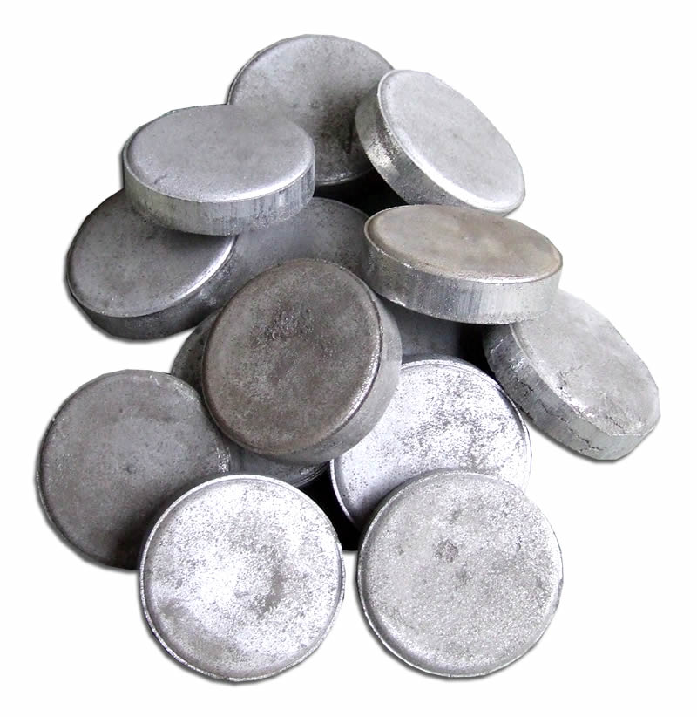 |  | Number: | 4821524616
 |  | Name: | Manganese Briquettes / Manganese Tablets / Manganese Alloys
 |  | Spec:
 |  | Memo:
 |  | Class: | Manganese alloy

Product Readme
ANALYSIS | ENGLISH | CHINESE
Manganese | Percent: 75/80/85/90 | 锰含量:75%,80%,85%,90%
Aluminum | Percent: 25/20/15/10 | 铝含量:25%,20%,15%,10%
Size | Tablets overlaying stacked in cylindrical shape  Diameter: 10-90 MM  Height: 5-50 MM | 圆柱状  直径 10-90MM  高 5-50MM
Weight | 25g/200g/556g~1333g | 25克,200克, 556克~1333克
Density | 3.7~403g/cm³ | 3.7~4.3克/立方厘米
Colour Code | Silver grey  Purple (AA colour code ) | 银灰色  (AA colour code)
Packing | Plastic shrink-wrap or foil wrapped  rolls of 3~5 tablets each  Packing in cardboard boxes  6 rolls each box (10 or 30 tablets/Box) | 塑料膜紧裹或金属箔片包裹成卷,  每卷3~5片,  每盒六卷
Application | Tablets and mini-tablets are mainly focused to the aluminum industry for alloying application | 主要应用于铝合金生产工业
